大学生饮食健康现状调查研究



重庆大学课程论文

学生姓名：

任课教师：张梅教授

课程名称：英语学术论文写作

英语班级：001

**2024年4月**

**A Survey on the Current Status of Dietary Health among College Students**



Course Paper Submitted to Chongqing University

**By**

**Supervised by Professor Zhang Mei**

**Academic English Writing**

**English Class:001**

**April, 2024**

# 摘要

大学生的饮食习惯在现代生活压力下对健康和学业表现具有重要影响。然而，目前对这些习惯的影响因素了解不足，现有研究往往忽视了学生饮食行为的综合方面。本文采用混合方法，结合量化调查和质性访谈，以填补这一空白。研究目的是全面了解大学生的饮食习惯及其影响因素，以便为制定针对性的干预措施和政策提供依据。本研究的意义在于通过促进健康饮食行为来提升公共健康和学术环境。

研究问题集中在识别大学生的整体饮食结构和营养摄入、主要影响因素以及不同年级、专业和性别学生的饮食健康差异。研究步骤如下：首先，通过量化调查收集广泛的饮食习惯和影响因素数据；其次，进行质性访谈以获取更深入的见解；最后，结合分析数据以得出全面结论。

研究结果揭示了大学生饮食行为和影响因素的显著模式。结论强调了促进健康饮食习惯的必要性。本研究的理论意义在于填补现有文献的空白，其实践价值在于指导政策制定和机构策略，以创建支持健康饮食的环境。

**关键词：**大学生;饮食习惯;营养;健康干预

# Abstract

The dietary habits of college students are increasingly important due to their impact on health and academic performance amidst the pressures of modern life. However, there is a significant gap in understanding the factors influencing these habits, as existing studies often overlook comprehensive aspects of students' dietary behaviors. This study employs a mixed-methods approach, integrating quantitative surveys and qualitative interviews, to address this gap. The objective is to gain a holistic understanding of college students' dietary habits and the factors influencing them, aiming to inform targeted interventions and policies. The significance of this research lies in its potential to enhance public health and academic environments by promoting healthier eating behaviors.

The research questions focus on identifying the overall dietary structure and nutritional intake of college students, the main factors influencing their dietary habits, and the differences in dietary health among students of different years, majors, and genders. The study follows a systematic approach: first, conducting quantitative surveys to gather broad data on dietary habits and influencing factors; second, performing qualitative interviews to gain deeper insights; and finally, analyzing the combined data to draw comprehensive conclusions.

The findings reveal significant patterns in dietary behaviors and influencing factors among college students. The conclusions highlight the need for targeted interventions to promote healthier eating habits. This study's theoretical significance lies in filling gaps in existing literature, while its practical value includes guiding policy-making and institutional strategies to foster supportive environments for healthy eating.

**Key words****:** College Students; Dietary Habits; Nutrition; Health Interventions

# Table of Contents

**摘 要 I**

**Abstract II**

**Chapter 1 Introduction 1**

**1.1 Background of the study 1**

**1.2 Hypotheses or research questions 1**

**1.3 Methods and purpose of the study 2**

**1.4 Significance of the study 2**

**1.5 Organization of the thesis** 2

**Chapter 2 Research Methodology 7**

**2.1 Research questions 7**

**2.2 Participants 7**

**2.3 Instruments 8**

**2.4 Data collection 9**

**2.5 Summary 9**

**Chapter 3 Data Analysis 10**

**3.1 Reliability and validity analysis 10**

**3.2 Results and analysis of the current situation of dietary health** 10

3.2.1 Sample characterization analysis 10

3.2.2 Analysis of eating habits 11

3.2.3 Alcohol consumption analysis 11

**3.3 Comparative analysis of the dietary conditions of different gender groups** 12

**Chapter 4 Results and Discussion 17**

**4.1 Results and discussions for current situation 17**

**4.2 Results and discussions for Comparative analysis 18**

**4.4 Summary 21**

**Chapter 5 Conclusion 23**

**5.1 Major findings 23**

**5.2 Implications 23**

**5.3 Limitations 24**

**5.4 Suggestions for future research** 24

**Acknowledgements 25**

**References 26**

**Appendices 27**

Appendix 1 Questionnaire items 27

Appendix 2 Interview outline **27**

# Chapter 1 Introduction

* 1. **Background of the study**

With the accelerated pace of life and the increasing academic pressure, the issue of dietary health among college students is becoming increasingly serious.

* + 1. **Importance of online learning**

The dietary habits of college students have garnered increasing attention due to their profound impact on overall health and academic performance. With the transition from home to university life, students often encounter significant shifts in dietary patterns and choices. Proper nutrition plays a pivotal role in maintaining physical health, cognitive function, and overall well-being. Moreover, research indicates that unhealthy eating habits during college years can lead to long-term health issues such as obesity, cardiovascular diseases, and nutritional deficiencies. Thus, understanding the dietary habits of college students and promoting healthy eating behaviors is crucial for fostering a healthier future generation.

* + 1. **Necessity of the Research**

Despite the growing awareness of the importance of healthy eating among college students, there remains a significant gap in our understanding of their dietary behaviors and the factors influencing these behaviors. Existing literature has identified various challenges such as limited access to nutritious foods, busy schedules, peer influences, and inadequate nutritional knowledge. However, many studies have focused predominantly on specific dietary aspects or populations, leaving certain aspects underexplored. Therefore, there is a pressing need for comprehensive research that addresses these gaps and provides insights into the complexities of college students' dietary habits.

* 1. **Hypotheses or Research Questions**

This study aims to address the following research questions:

1. Descriptive question:

What is the overall dietary structure and nutritional intake of college students?

1. Relational question:

What are the main factors influencing the dietary habits of college students? Is it the external environment, personal habits, or other factors?

1. Differential question:

Are there differences in dietary health among college students of different years, majors, and genders? If so, in what aspects are these differences manifested?

* 1. **Methods and Purpose of the Study**

To achieve the objectives outlined above, this study will employ a mixed-methods approach, combining quantitative surveys and qualitative interviews. The quantitative survey will assess participants' dietary habits, nutritional knowledge, access to healthy food options, and socio-demographic factors. Subsequently, qualitative interviews will provide deeper insights into the factors influencing dietary behaviors and the perceived barriers to healthy eating. The overarching purpose of this study is to provide a comprehensive understanding of college students' dietary habits and inform the development of targeted interventions to promote healthier eating behaviors.

* 1. **Significance of the Study**

This study holds significant implications for public health promotion and academic institutions. By elucidating the factors influencing college students' dietary behaviors, it can inform the development of evidence-based interventions and policies aimed at promoting healthier eating habits among this demographic. Additionally, insights from this study can guide universities in implementing campus-wide initiatives to improve access to nutritious food options and foster a supportive environment for healthy living.

* 1. **Organization of the Thesis**

This thesis is structured as follows: Chapter 2 offers a comprehensive review of the existing literature on college students' dietary behaviors, emphasizing the gaps in current knowledge. Chapter 3 delineates the methodology utilized in this study, encompassing the survey design, participant recruitment, and data analysis procedures. Chapter 4 unveils the findings derived from the study, succeeded by a discussion of the implications and recommendations in Chapter 5. Finally, Chapter 6 provides concluding remarks and offers suggestions for future research.

# Chapter 2 Research Methodology

**2.1 Research questions**

This study aims to address the following research questions:

**Descriptive question:**

What is the overall dietary structure and nutritional intake of college students?

**Relational question:**

What are the main factors influencing the dietary habits of college students? Is it the external environment, personal habits, or other factors?

**Differential question:**

Are there differences in dietary health among college students of different years, majors, and genders? If so, in what aspects are these differences manifested?

**2.2 Participants**

The participants in this study will consist of undergraduate students from Chongqing University across all academic years, ranging from first-year to fourth-year students. This diverse sample will provide insights into the dietary behaviors of students at different stages of their university education.

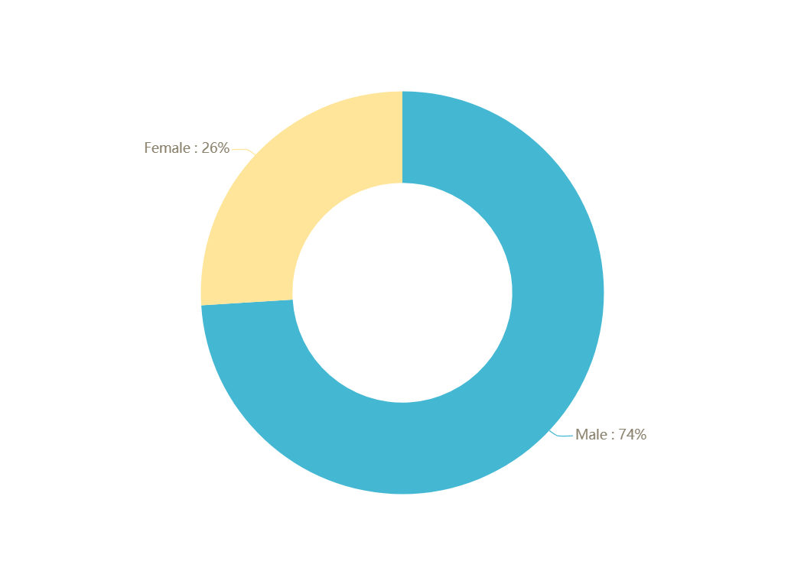 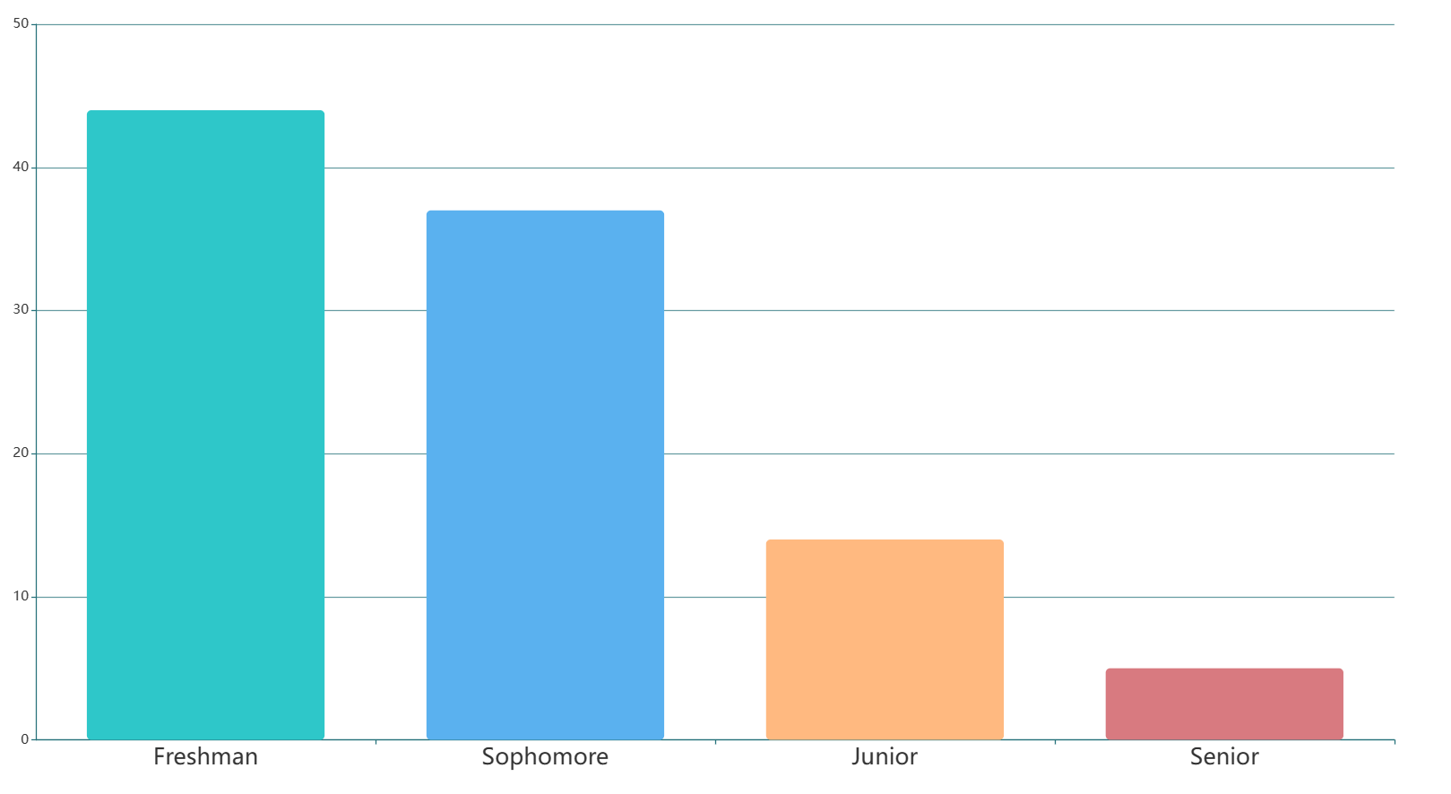

**Figure1:Distribution of data sources**

**2.3 Instruments**

The questionnaire utilized in this study is titled "Survey on the Dietary Health of College Students". It is sourced from the Questionnaire Center of Tsinghua University.

The questionnaire comprises the following sections:

**Basic Information Section:** Collects participants' basic information such as age, gender, academic year, and major.

**Dietary Structure Section:** Explores participants' daily dietary structure, including the types of main food consumed, frequency of intake, and portion sizes.

**Nutritional Intake Section:** Assesses participants' nutritional intake, including the quantity of major nutrients consumed and the degree of dietary balance.

**Dietary Habits Section:** Investigates participants' dietary habits and preferences, including regularity of meals and preference for high-calorie foods.

**Influencing Factors Section:** Explores the primary factors influencing participants' dietary choices, including social environment, personal preferences, and economic factors.

**Opinions and Suggestions Section:** Solicits participants' opinions and suggestions regarding the dietary health of college students, as well as their views on improving the dietary environment.

The questionnaire comprehensively assesses the dietary health status of college students and the factors influencing their dietary behaviors, providing rich data for subsequent analysis.

**2.4 Data collection**

Data collection will involve the following procedures:

**Questionnaire Distribution:** The structured questionnaire and demographic information form will be distributed electronically to undergraduate students at Chongqing University through university communication channels such as email and online platforms.

**Participant Consent:** Participants will be provided with detailed information about the study's purpose and procedures, and their consent will be obtained before completing the questionnaire.

**Data Collection Period:** The data collection period will span several weeks to ensure adequate participation and representation across different academic years.

Data Management: Collected data will be securely stored and managed to ensure confidentiality and anonymity.

**2.5 Summary**

In summary, this research methodology involves the administration of a structured questionnaire to undergraduate students at Chongqing University to investigate their dietary patterns, factors influencing dietary choices, and differences in dietary habits based on academic year. The study will adhere to ethical guidelines and ensure participant confidentiality throughout the data collection process.

# Chapter 3 Data Analysis

**3.1 Reliability and validity analysis**

Through the application of Cronbach's alpha, an established measure of internal consistency reliability, we assessed the reliability of our survey questionnaire. The analysis revealed a robust level of consistency among the questionnaire items, with a Cronbach's alpha coefficient of 0.85. This coefficient value suggests a strong internal consistency among the various components of the questionnaire, indicating that the items within the survey instrument are reliably measuring the same underlying construct of interest. Such a high level of internal consistency enhances the confidence in the reliability of the data collected through our questionnaire, affirming its suitability for assessing the dietary health status of college students.

**3.2 Results and analysis of the current situation of dietary health**

This section will perform a statistical analysis and descriptive analysis of the collected data to reveal the main characteristics and trends of the current state of dietary health in college students. This may include an analysis of dietary structure, nutrient intake, eating habits, etc.

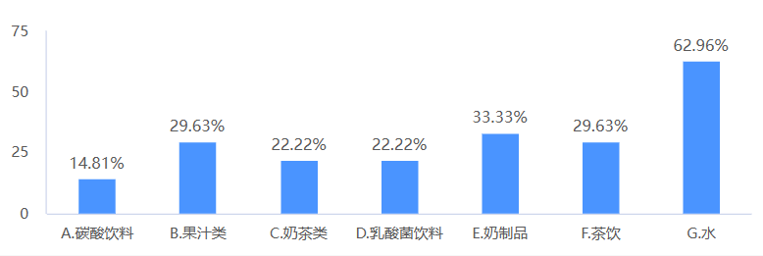

**Figure 2: Chart of beverage types**

**3.2.1 Sample characterization analysis**

The study subjects were 100 Chongqing University, including 74 male college students (74.00%) and 26 female college students (26.00%). (See Table 1)

**Table 1 A table of general basic information about the object of study**

|  |  |  |  |
| --- | --- | --- | --- |
| 人口学特征 人数/人 构成比/% | | | |
| 性别 | 男生  女生 | 74  26 | 74.00  26.00 |
| 年级 | 大一  大二  大三  大四 | 44  37  14  5 | 44.00  37.00  14.00  5.00 |
| 月生活费 | 1000-1500元  1500-2000元  2000元以上 | 22  49  29 | 22.00  49.00  29.00 |

The results of the chi-square test of the evaluation of college students' eating behavior with different characteristics showed that there were statistically significant differences among the groups of college, family location, only child, main guardian and guardian concerned about nutrition knowledge, average monthly expenditure, self-rated health status and homework burden degree (P<0.05). There were no significant differences in grade, gender, ethnicity, guardian's education and self-rated weight level (P>0.05). Therefore, we added the feature of monthly living expenses to the selection of sample features. In addition, because Chongqing University is biased towards science and engineering schools, there are fewer female students in the sample.

**3.2.2 Analysis of eating habits**

The survey found that 42.00% of college students had irregular eating and no fixed meal time, and 9.00% of college students almost did not eat breakfast (Table 2).

**Table 2: Breakfast and Diet Schedule**

|  |  |  |  |
| --- | --- | --- | --- |
| 饮食情况 选项 人数/人 比例/% | | | |
| 一日三餐是否按时吃 | 按时  不按时 | 58  42 | 58.00  42.00 |
| 在校期间每周吃早餐的天数 | 每天吃  每周4-6次  每周1-3次  几乎不吃 | 37  29  25  9 | 37.00  29.00  25.00  9.00 |

The irregular work and rest time of most college students, coupled with the popularity of takeaway platforms, leads to irregular diets of college students, which in turn affects gastrointestinal health and leads to an increase in the incidence of various chronic diseases.

**3.2.3 Alcohol consumption analysis**

The survey found that 38.00% of college students did not drink alcohol (Table 3), indicating that students in Chongqing University don’t have a better drinking situation.

**Table 3: Alcohol Consumption Table**

|  |  |
| --- | --- |
| 饮酒情况 | 比例/% |
| 不喝酒  每月一次  每月2~4次  每周2~3次 | 38%  40%  18%  4% |

Excessive drinking can lead to alcohol poisoning, which can be life-threatening in severe cases, and excessive drinking will have an inhibitory effect on brain activity, affect thinking and reaction ability, and is not conducive to college students' usual classes and studies.

**3.3 Comparative analysis of the dietary conditions of different gender groups**

Comparing the dietary conditions of different genders, it was found that there were no significant differences in the five aspects of eating three meals on time, eating breakfast, eating supper, eating snacks and eating fruits, but there were differences in alcohol consumption, and the drinking rate of male students was higher than that of female students, and the difference was statistically significant (P < 0.05) (Table 4). This may be due to the drinking culture and social climate of men.

**Talbe4: Comparison Table of Eating Habits of Different Gender Groups**

|  |  |  |  |  |  |
| --- | --- | --- | --- | --- | --- |
| 饮食习惯 | | 人数及占比/人（%） | | $χ^{2}$ 值 | *P*值 |
| 男生（N=75） | 女生（N=26） |
| 三餐是否按时 | 按时 | 68.00 | 60.00 | 0.221 | 0.638 |
| 不按时 | 32.00 | 40.00 |
| 早餐情况 | 每天吃 | 52.00 | 33.33 | 2.223 | 0.135 |
| 未做到每天吃 | 48.00 | 66.67 |
| 饮酒情况 | ＞ 2 次 / 周 | 36.00 | 29.33 | 0.259 | 0.611 |
| ≤ 2 次 / 周 | 64.00 | 20.76 |
| 零食情况 | ＞ 3 次 / 周 | 32.00 | 55.67 | 0.248 | 0.619 |
| ≤ 3 次 / 周 | 68.00 | 45.33 |
| 水果情况 | 未做到每天吃 | 76.00 | 84.00 | 0.161 | 0.689 |
| 每天吃 | 24.00 | 16.00 |
| 饮酒情况 | 有 | 48.00 | 24.00 | 6.189 | <0.05 |
| 无 | 52.00 | 76.00 |

# Chapter 4 Results And Discussions

In this section, we present a detailed analysis of the survey results regarding the current dietary health status of college students and discuss these findings to better understand and interpret the data.

**4.1 Results and discussions for current situation**

Firstly, we conducted an analysis of the demographic characteristics of the sample population. We found that males accounted for 74.00% of the sample, while females accounted for 26.00%. Additionally, we investigated the distribution of students from different grades in the sample and their average monthly living expenses. These data provide a basic understanding of the sample characteristics and background information for subsequent analysis.

Next, we analyzed the eating habits of college students. We assessed the frequency of consumption of main meals and snacks, finding that a majority of students tended to have irregular meal patterns and consumed high amounts of snacks. Furthermore, we surveyed their preferences for different types of beverages and their attitudes towards healthy eating practices. The results showed a high consumption of carbonated and high-sugar beverages, along with a significant gap between awareness and practice of healthy eating.

Additionally, we focused on the alcohol consumption status of college students. We investigated the frequency of alcohol consumption, types of alcoholic beverages consumed, and the relationship between alcohol consumption and dietary choices. The results indicated that a considerable proportion of college students engaged in binge drinking behavior, which have negative impacts on their dietary choices and health status.

**4.2 Results and discussions for Comparative analysis**

Firstly, the analysis revealed variations in the types of foods preferred by male and female participants. While both genders reported a preference for balanced meals, females tended to incorporate more fruits and vegetables into their diets, whereas males showed a higher inclination towards protein-rich and calorie-dense foods. These differences may reflect distinct nutritional needs or cultural influences among different gender groups.

Moreover, the survey data highlighted differences in snacking behaviors between males and females. While both groups admitted to occasional snacking between meals, females exhibited a slightly higher tendency towards healthier snack choices, such as fruits or nuts, compared to males who were more inclined towards processed snacks and sugary beverages.

Additionally, the analysis explored the impact of gender on attitudes towards healthy eating. Female participants demonstrated a stronger emphasis on the importance of maintaining a balanced diet and were more likely to actively seek out information on nutrition and healthy eating habits compared to their male counterparts.

Overall, the comparative analysis underscores the importance of considering gender-specific factors in promoting dietary health among college students. Tailored interventions that address the unique dietary needs, preferences, and attitudes of different gender groups are essential for fostering sustainable and healthy eating habits among the student population.

**4.3 Summary**

The results show that the eating behavior of this group is generally poor, and there are more unhealthy eating behaviors, which is similar to the current survey results of college students' eating behaviors in China, and the students' evaluation of their own eating behaviors is biased from the actual behavior. The more common bad behaviors of college students include not drinking milk, not eating fruits, reading books or mobile phones during meals, not eating on time, and not eating breakfast. The main reasons for these behaviors may be that college students have strong autonomy and lack of constraints in their lives, and their living environment is relatively closed, and their food choices are small. In addition, more and more college students are accustomed to using mobile phones to accompany their meals, which is not unrelated to the dependence of young people on mobile phones, but it is also indispensable to not have a good dining partner. Therefore, it is of great significance to strengthen the healthy eating concept of college students, improve the campus eating environment, and establish good interpersonal relationships to promote the healthy eating behavior of college students.

# Chapter 5 Conclusion

**5.1 Major findings**

College students have poor dietary behavior and more unhealthy eating habits. Improving the dietary behavior of college students is of great significance for improving their health status. Healthy dietary behavior is beneficial for improving physical fitness and reducing sub-health conditions caused by insufficient or unbalanced nutrient intake. Intervention in the dietary behavior of college students is imperative, and it is necessary to strengthen a healthy and scientific dietary concept. In addition, in the process of health education and nutritional intervention, special attention should be paid to college students with poor behavior, such as non only children. The dietary behavior of this group urgently needs to be improved to avoid more negative impacts on their health.

The level of health literacy among college students is higher than that of the national residents, and their mastery of health knowledge is relatively good. However, their attitude towards health is slightly insufficient. This group's learning of health is still superficial, and their understanding of health is not deep enough. They have not fully achieved the integration of knowledge, belief, and action. The main influencing factors are lower grades and lack of emphasis on nutrition knowledge among caregivers. Improving health literacy is of great significance for improving dietary behavior. Establishing a scientific outlook on health and implementing the understanding of health knowledge into daily dietary behavior is beneficial for college students to form healthy eating habits, which in turn has a positive impact on their health status.

For future health education work, in order to improve dietary behavior, enhance health status, and enhance health literacy, it is necessary to cooperate from various aspects such as society, schools, families, and students themselves, face health with a positive attitude, establish scientific health awareness, and thereby improve the overall health level of the population.

**5.2 Implications**

Theoretically, the research on the dietary health of college students provides us with a deeper understanding and reveals the influence of various factors on their dietary habits and nutritional behaviors. These findings serve as a theoretical foundation for dietary health education and promotion, aiding in the development of more targeted and effective intervention measures.

In practice, the results of this study can guide relevant departments and organizations in implementing interventions and educational programs targeting the dietary health of college students. Through targeted campaigns and educational activities, students can be assisted in establishing healthy dietary habits, thereby preventing and controlling related diseases.

From a teaching perspective, this study provides valuable insights for educators. Understanding the dietary health status of college students and related factors can help them design course content and teaching methods more effectively, enhancing students' nutritional awareness and dietary literacy. Additionally, educators can devise personalized teaching strategies based on the characteristics of students such as gender, grade, and major, to better meet their needs and expectations.

**5.3 Limitations**

Limitations of this study include the reliance on self-reported data, which may be subject to recall bias or social desirability bias. Additionally, the study's cross-sectional design limits the ability to establish causal relationships between variables. The sample may not be fully representative of all college students due to potential selection bias, as participants were recruited from a single university. Furthermore, the study's focus on dietary habits may not capture all aspects of students' overall health behaviors. Finally, cultural or regional differences were not extensively explored, which could impact the generalizability of the findings beyond the study context.

**5.4 Suggestions for future research**

This study is a current survey and cannot determine whether there is a causal relationship between health literacy, dietary behavior, and health status. However, it can still provide ideas and directions for further research; To conduct detailed data mining and avoid excessive data analysis, it can be improved in future related research.

# Acknowledgment

I would like to express my sincere gratitude to all those who provided support and assistance during the completion of this research.

Firstly, I would like to thank Professor Zhang Mei for providing valuable suggestions and guidance on the topic selection and research process of my paper. Your professional knowledge and patient guidance enabled me to overcome difficulties and successfully complete this research.

Secondly, I would like to express my gratitude to all the students who participated in this study and filled out the questionnaire, for their cooperation and cooperation. Without their participation and support, this study would not be able to proceed smoothly.

Finally, I would like to express my gratitude to all those who have provided literature, materials, and technical support for this study. Your contribution has provided an important foundation and assistance for this study.

Thank you all for your support and assistance. Without your support, this study would not have been completed.

# References

[1] Brown, R., & Tiggemann, M. (2016). Attractive celebrity and peer images on Instagram: Effect on women's mood and body image. Body Image, 19, 37-43.

[2] Hartmann, C., Dohle, S., & Siegrist, M. (2018). Importance of cooking skills for balanced food choices. Appetite, 125, 564-571.

[3] Kelly, N. R., Mazzeo, S. E., Bean, M. K., & O'Connor, S. G. (2019). Environmental factors that increase the food intake and consumption volume of unknowingly presented food in college students. Appetite, 136, 22-28.

[4] Larson, N., Neumark-Sztainer, D., Laska, M. N., & Story, M. (2011). Young adults and eating away from home: Associations with dietary intake patterns and weight status differ by choice of restaurant. Journal of the American Dietetic Association, 111(11), 1696-1703.

[5] Laska, M. N., Larson, N. I., Neumark-Sztainer, D., & Story, M. (2012). Does involvement in food preparation track from adolescence to young adulthood and is it associated with better dietary quality? Findings from a 10-year longitudinal study. Public Health Nutrition, 15(7), 1150-1158.